Sleep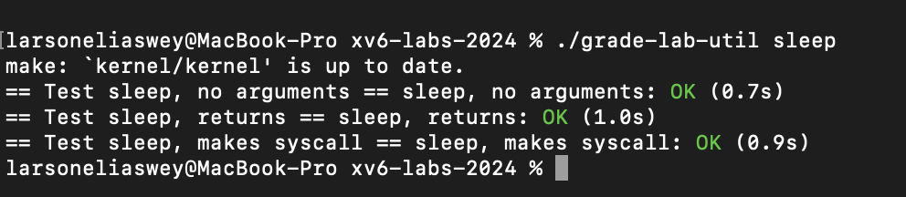
pingpong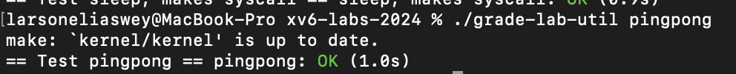
Primes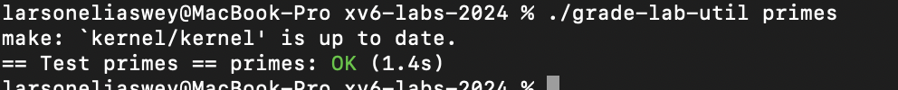
find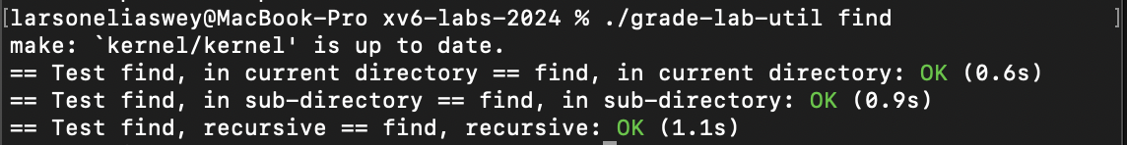
xargs
